AWS Business Intelligence Engineer Nanodegree – Project 2: Building an Application on Amazon Q Business

Automating the Career Coaching Process for Career4All

1. Executive Summary
Career4All, a professional career development platform, faced operational inefficiencies in its manual career coaching process. The existing workflow required coaches to manually analyse learners’ CVs against job descriptions, identify skill gaps, and recommend relevant training programs. This process was time-consuming, inconsistent across coaches, and unable to scale with the growing learner base.
I designed and implemented a fully automated AI-powered career coaching application using Amazon Q Business to address these challenges. The solution leverages AWS’s no-code capabilities to streamline skill-gap analysis, automate training recommendations, and enforce secure access control, transforming Career4All’s manual system into a scalable, data-driven platform.

2. Project Objectives
The primary goals of this project were to:
- Automate skill-gap analysis by comparing student CVs and job descriptions using Amazon Q Business.
- Generate accurate, personalised training recommendations from Career4All’s course catalogue.
- Enable Career Coaches to refine recommendations through natural language prompts.
- Enhance scalability, efficiency, and consistency across the coaching process.
- Secure the application with user-based access controls and keyword moderation filters.

3. Project Overview
As part of the Career4All Cloud Transformation Initiative, this project focused on building a modular and intelligent coaching assistant capable of:
- Ingesting structured and unstructured documents (PDFs, job profiles, CVs).
- Analysing text data to detect skill mismatches.
- Providing real-time training recommendations and schedules from both static and dynamic sources.
The final solution was developed on Amazon Q Business and integrated with Amazon S3, IAM Identity Centre, and Access Control Lists (ACLs) for secure and reliable operation.

4. Application Architecture
The Career4All Coaching App was designed with the following functional architecture:
- Frontend: Amazon Q Business interface with multiple input and output cards.
- Data Layer: Amazon S3 bucket hosting Career4All’s training catalogue PDFs and synchronised data sources.
- Logic Layer: Skill analysis and recommendation logic built within Q App workflows.
- Security Layer: Access controls are configured through the IAM Identity Centre and ACL restrictions.
- Moderation Layer: Global keyword filtering for prohibited content (e.g., gambling, casino).

5. Application Components

Input Cards & Output Cards
To validate performance, I tested the app with a sample CV and job description.
The output successfully demonstrated:
- Clear identification of skill gaps and matched skills.
- Tailored course recommendations based on detected deficiencies.
- A structured, personalised learning schedule generated through AI refinement.

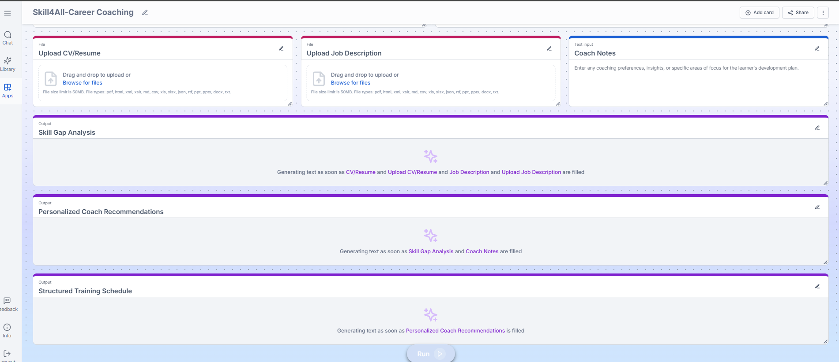
Figure 1 – Amazon Q app Input & Output Card

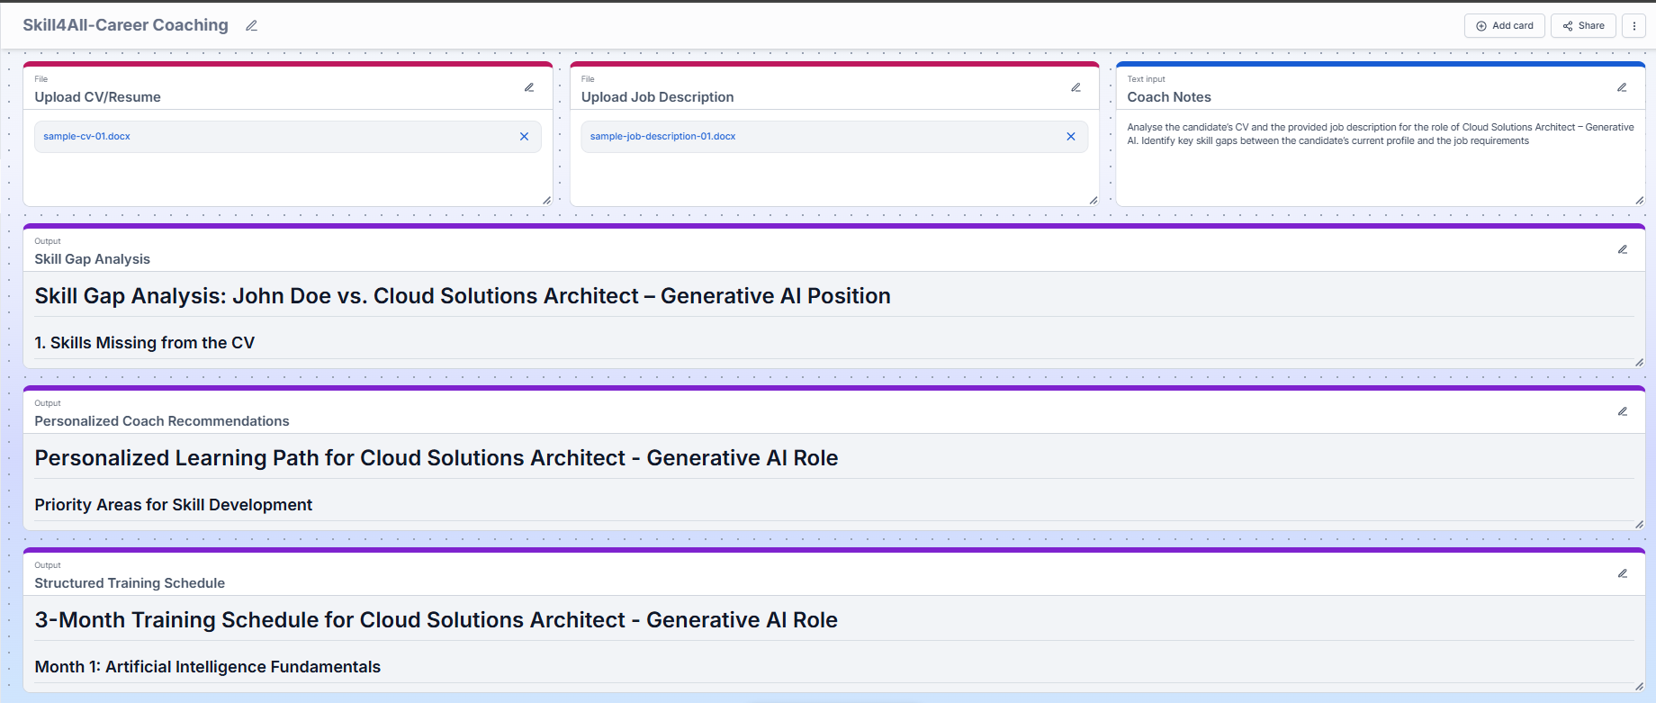
Figure 2 – Job Matching Generation Output

Figure 3 – Skill Gap Analysis Prompt

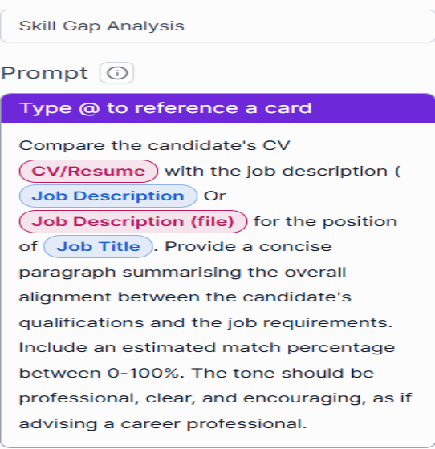

6. Data Integration and Synchronisation
The app integrates both static and dynamic data sources:
- A manually uploaded PDF catalogue from Career4All’s internal repository.
- An Amazon S3 bucket (coaching-catalogues) configured for real-time training updates.
- A daily scheduled sync was set up to ensure training materials remain current.
This configuration guarantees that the coaching recommendations stay aligned with the latest available learning resources.

Figure 4 (A) - Data Sources
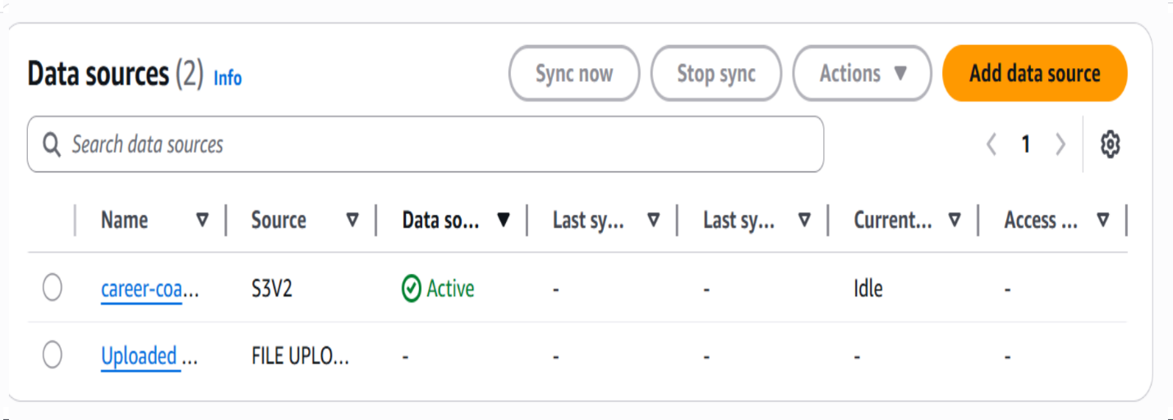
Figure 4 (B) - Data Sources Uploaded Files Content
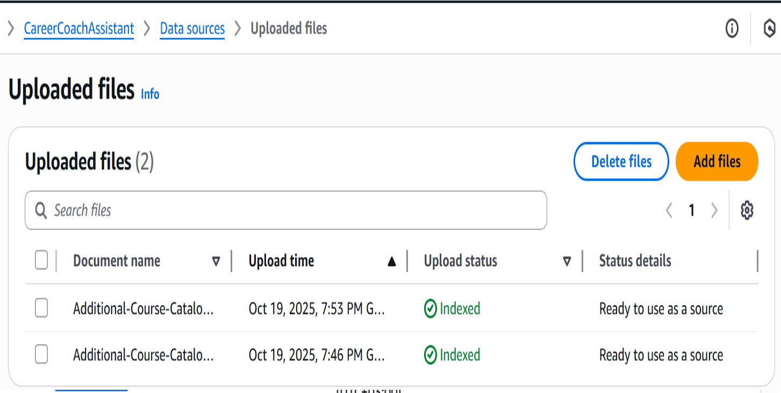

Figure 4 (C) - Data Sources S3 Bucket Uploaded Content
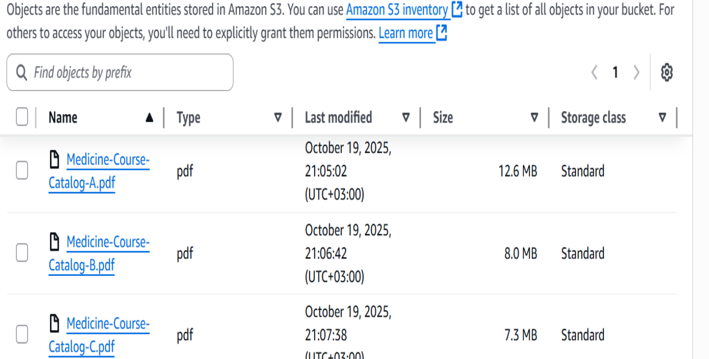
Figure 4 (D) - Data Sources Upload and Active Indexing
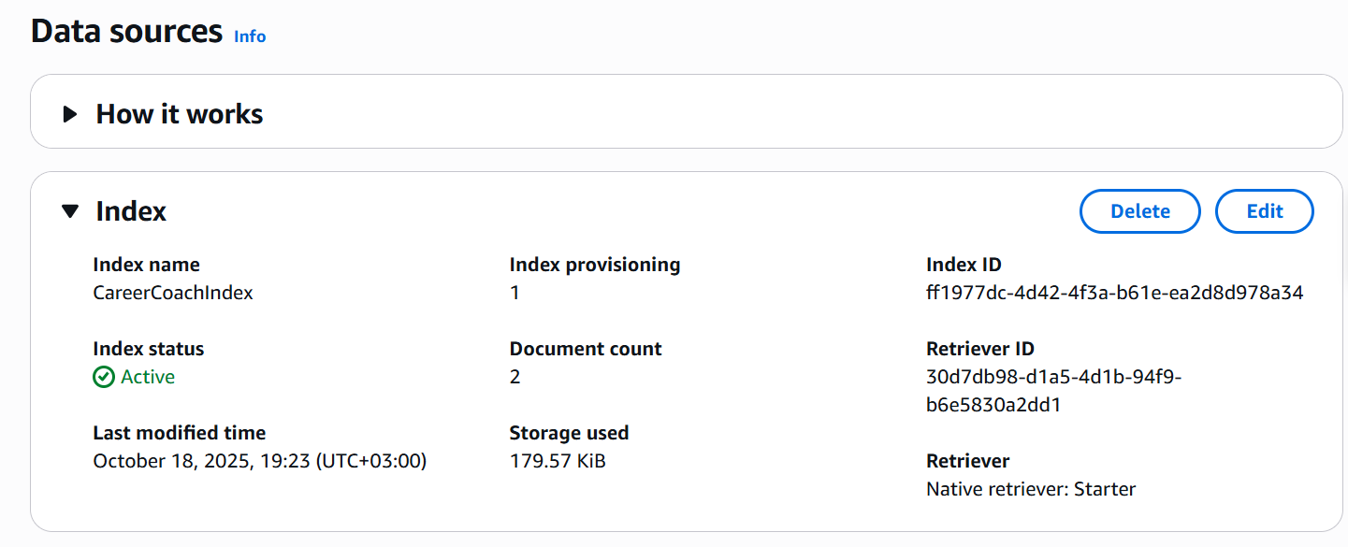
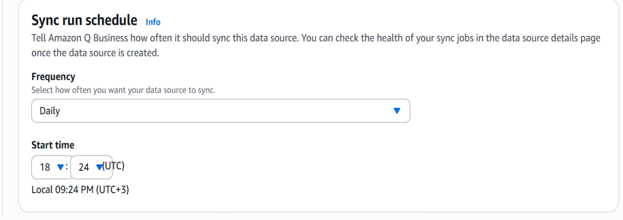
Figure 4 (E) – Sync Run Schedule

7. Security and Access Control
Security was implemented at multiple levels:
- The CareerCoaches group and users (career.coach.one and career.coach.two) were configured via IAM Identity Centre.
- An Access Control List (ACL) was created and applied to the data source to restrict course visibility based on user roles.
- Access testing confirmed that restricted courses were visible only to authorised users.
Figure 5 (A) – Access Control configuration
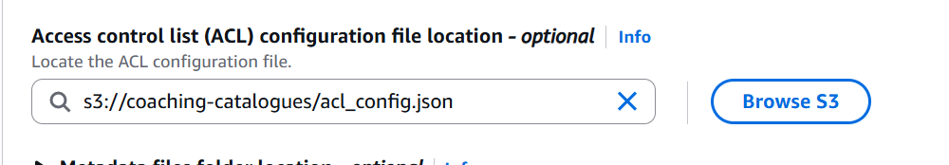

Figure 5 (C) – ACL File Upload
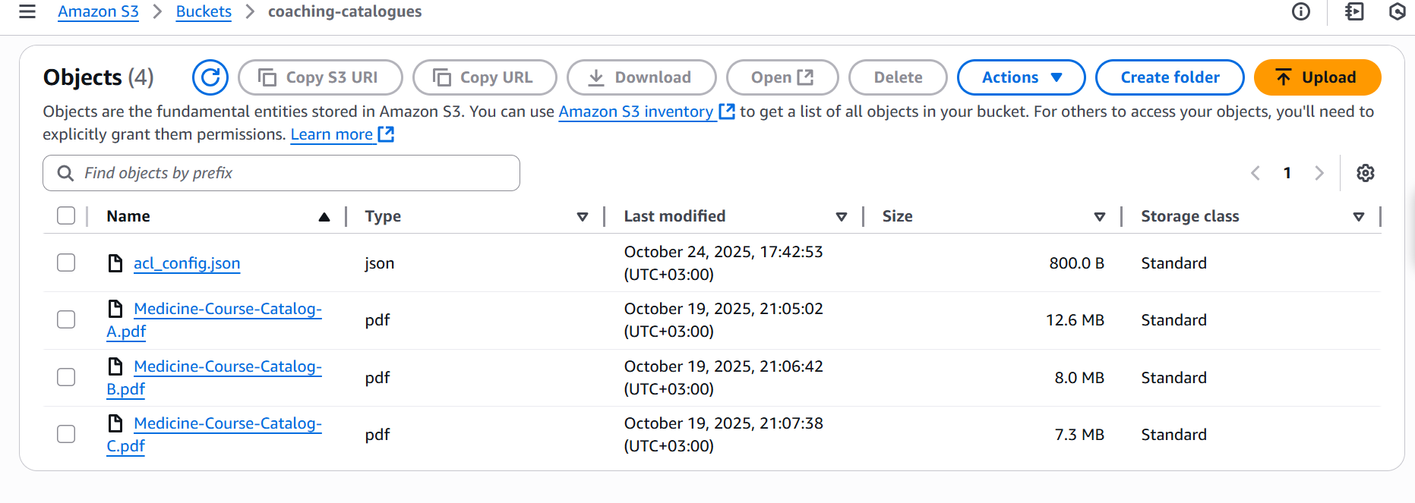
5 (B) – Access Control configuration JSON file
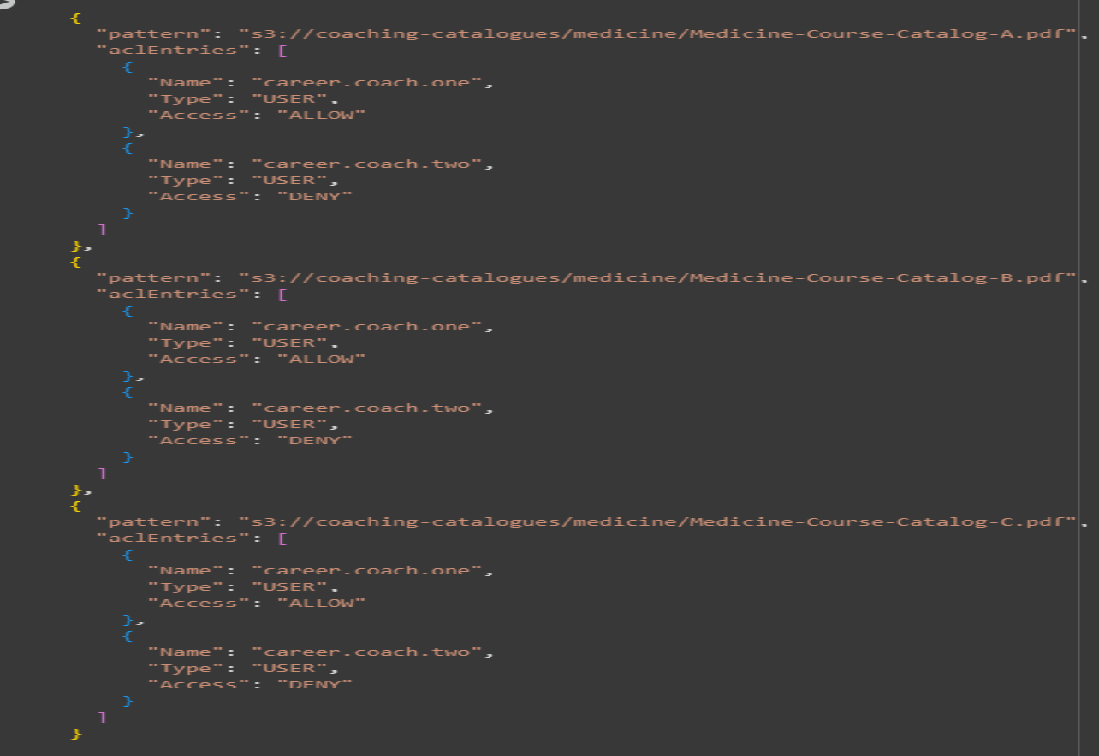

Figure 5 (C) – Denied Access Example
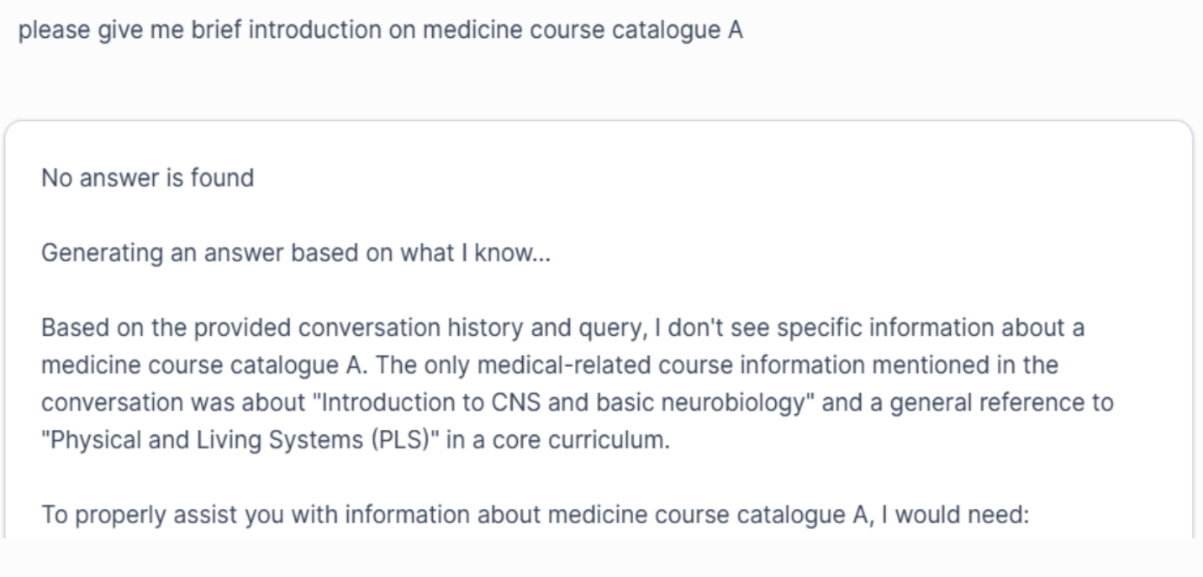
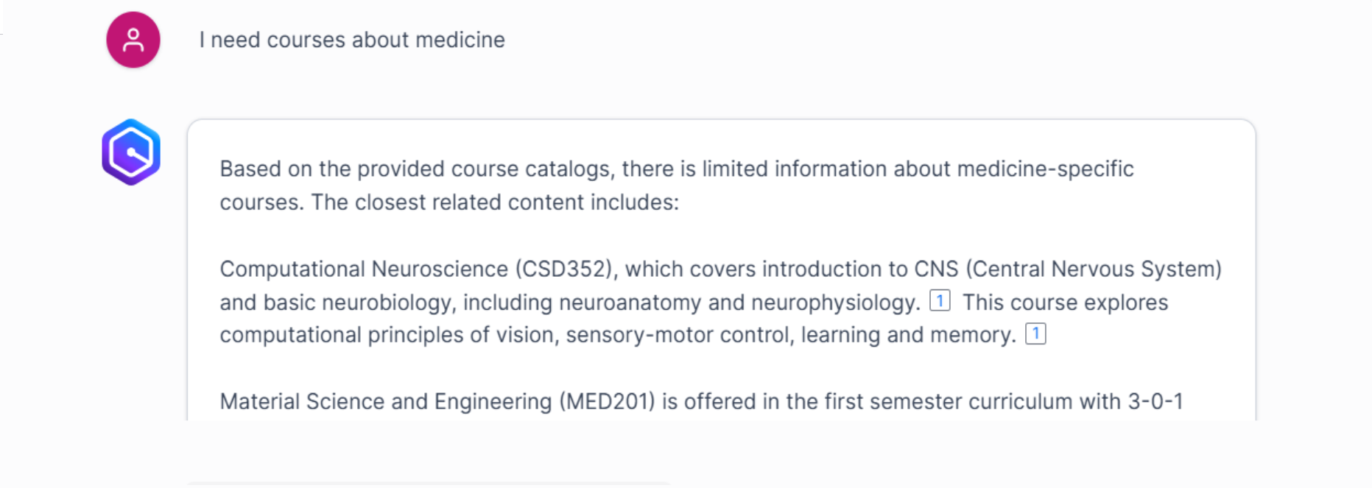

Figure 5 (D) – Granted Access Example
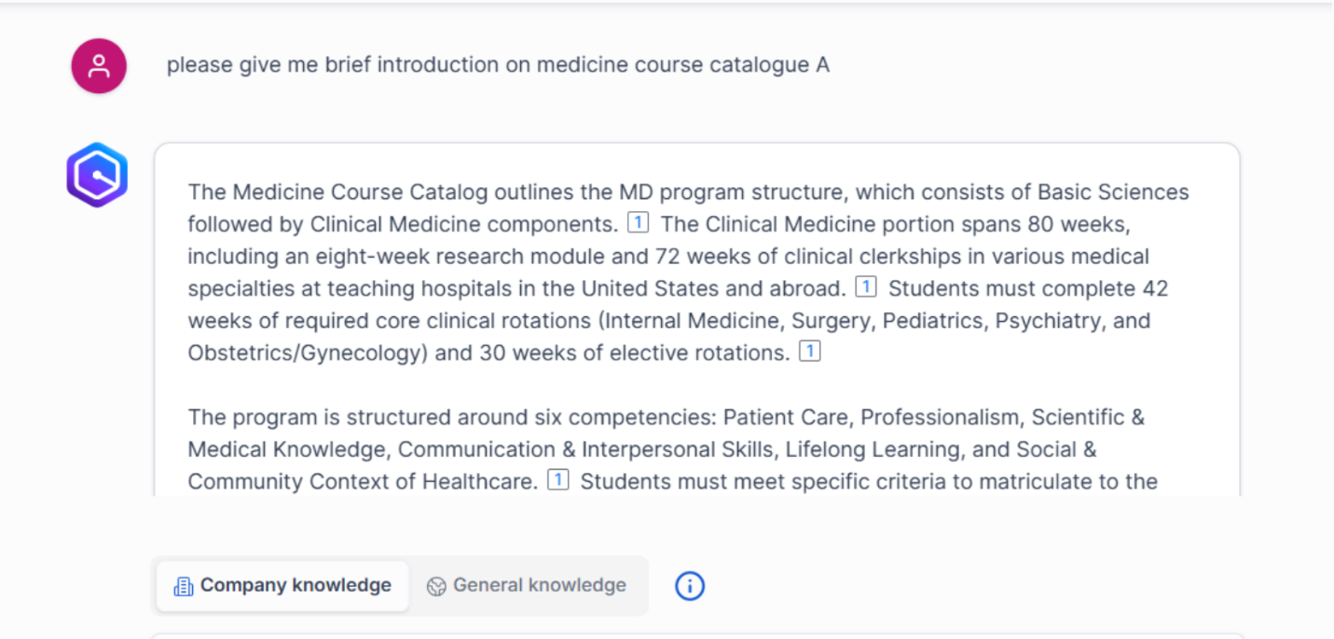
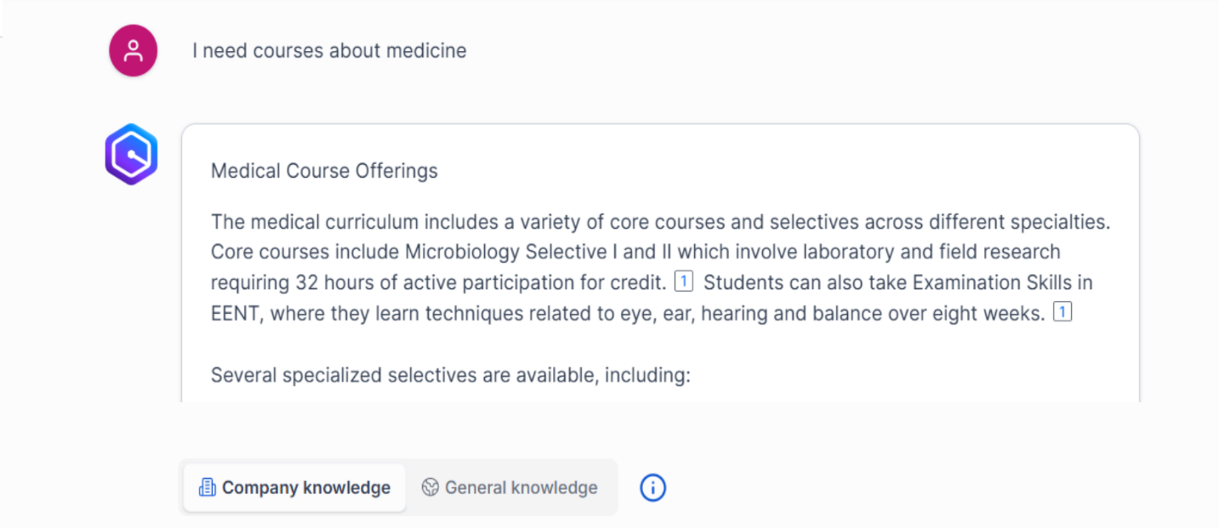
8. Content Moderation
A Global Controls policy was established in Amazon Q Business to block restricted keywords such as “Gambling”,” Attack”,” Self-harm and “Casino”. This ensured compliance with Career4All’s content integrity standards and maintained a safe, professional learning environment.
Figure 6 (A) – Blocked Words
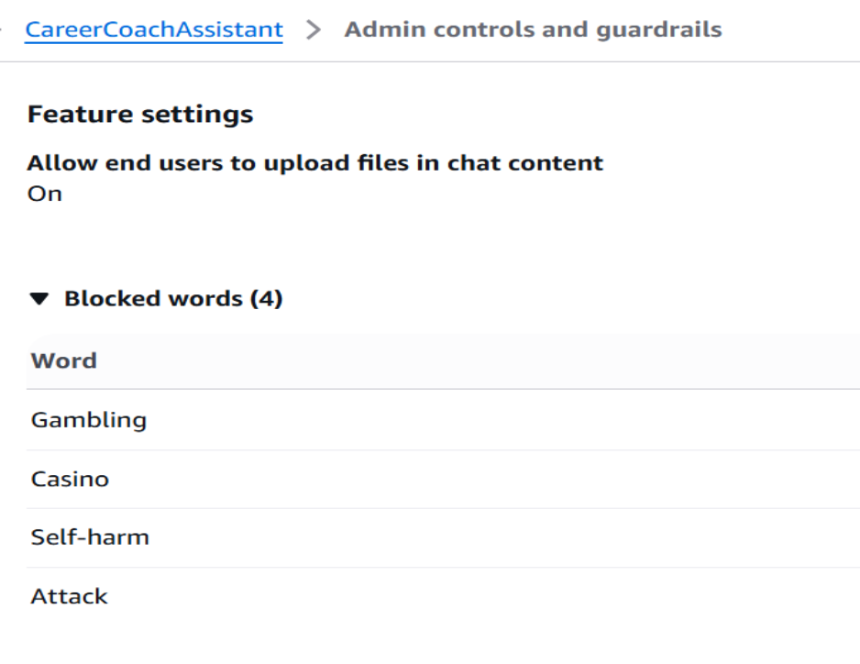
Figure 6 (B) - Topic Specific Controls
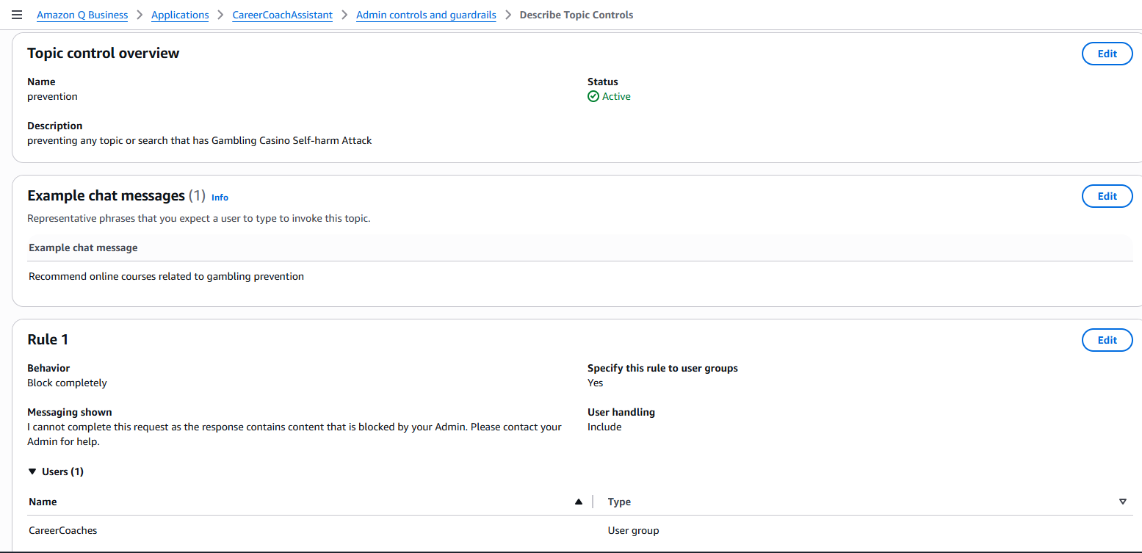

Figure 6 (C) – Blocked Word Practical Example
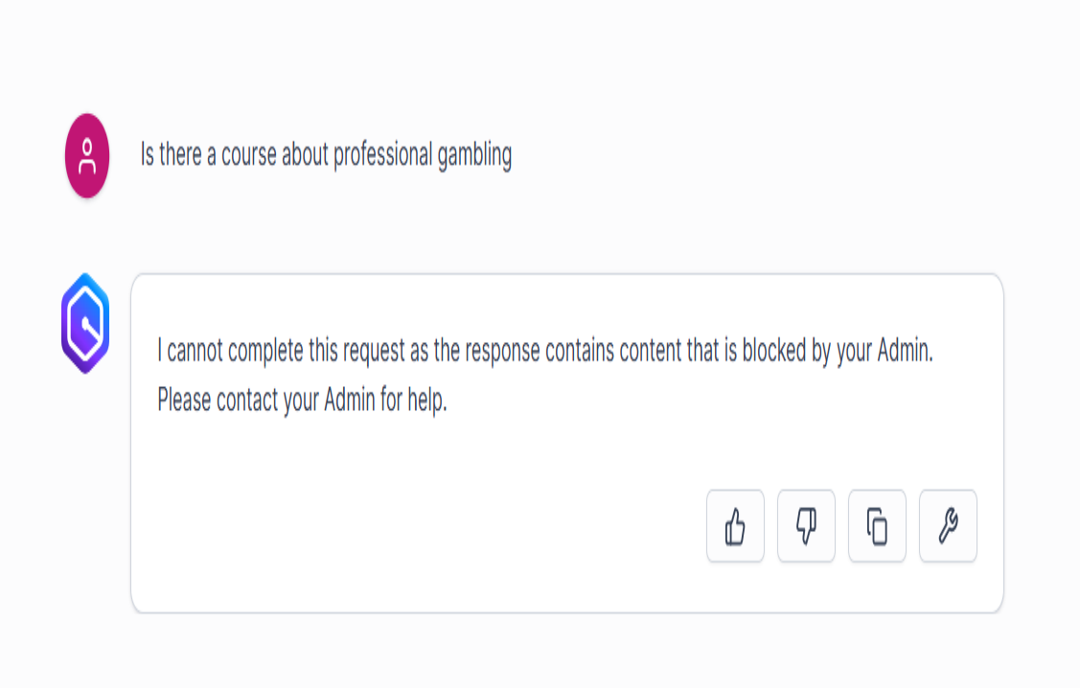

9. Application Verification and Publishing
Once functionality and security were validated, the Career Coaching App was:
- Shared with the CareerCoaches group.
- Custom Categorisation including “Career”,” Coaching” and “AI-powered”.
- Published and verified within Amazon Q Business for production readiness.
Figure 7 (A) – Custom Labels
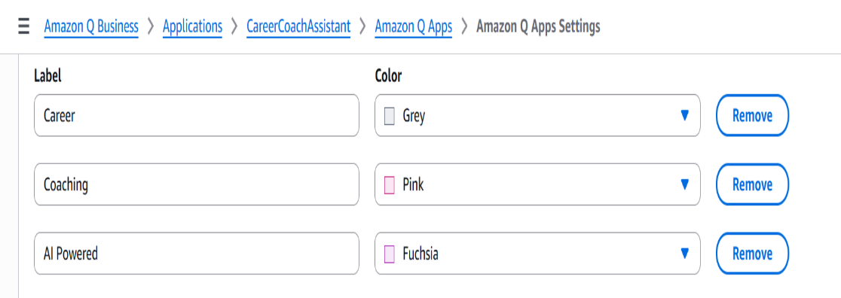
Figure 7 (B) – Custom Labels
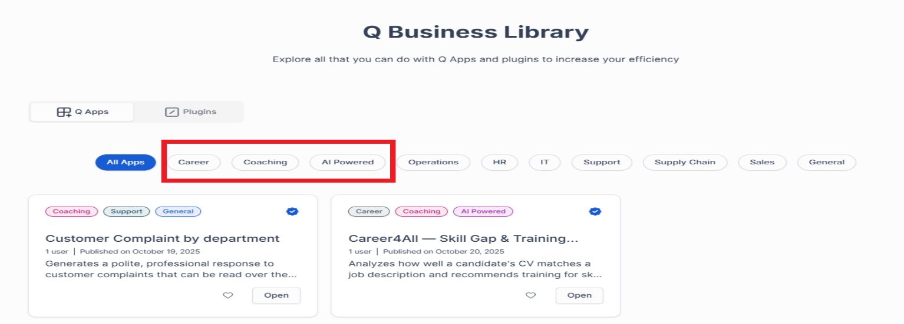
Figure 7 (C) – Career4All App Sharing and Verification
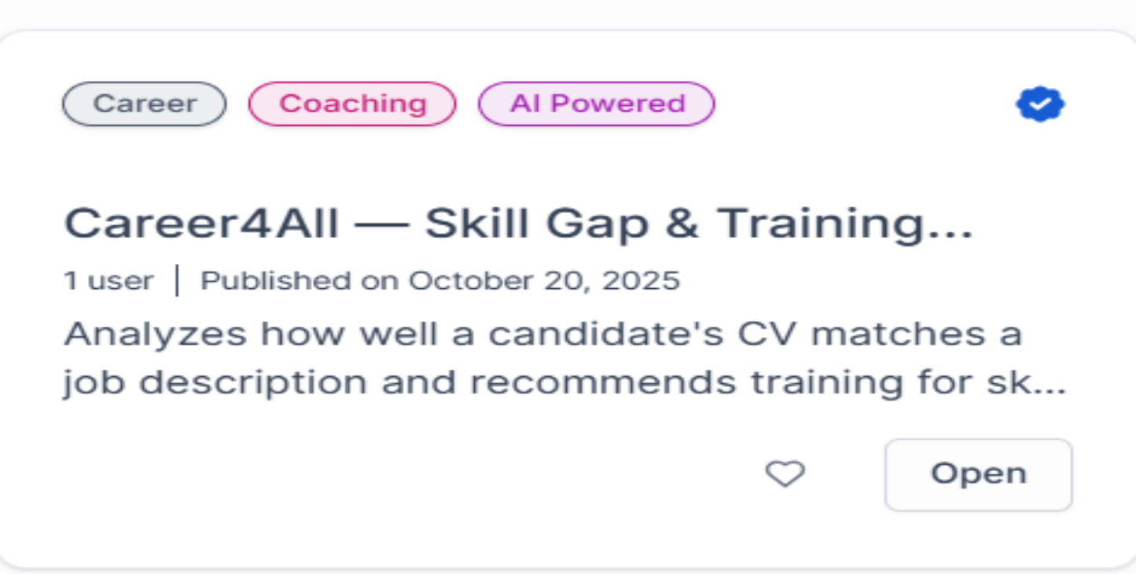

10. Key Achievements
- Reduced the time spent on skill-gap analysis and training mapping by over 90%.
- Enabled automated updates through Amazon S3, ensuring continuously fresh training data.
- Established a secure, role-based access system protecting proprietary course content.
- Enhanced consistency and scalability across the coaching team.
- Delivered a fully functional, production-ready AI career coaching assistant.

11. Lessons Learned
Building this solution provided valuable hands-on experience in:
- Leveraging Amazon Q Business for no-code intelligent automation.
- Designing secure, scalable architectures within AWS ecosystems.
- Integrating structured and unstructured data for analytical use cases.
- Balancing automation with human refinement to preserve quality insights.

12. Conclusion
Through this project, I successfully transformed Career4All’s manual coaching workflow into a data-driven, automated, and scalable solution using Amazon Q Business.
The application demonstrates how AI and cloud integration can redefine traditional business processes, reducing overhead, improving accuracy, and empowering professionals with real-time, intelligent tools.
This project not only meets the AWS/Udacity Nanodegree criteria but also stands as a portfolio-grade enterprise case study, reflecting real-world AWS solution engineering, business intelligence design, and applied automation.

